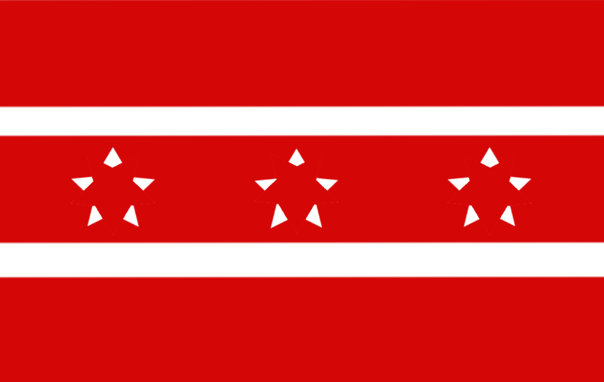Republic of Miraguay

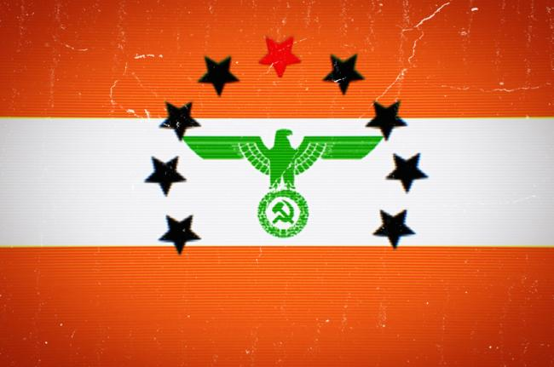United Socialist Republics

TREATY OF OFFICIAL COOPERATION

Article 1: General Provisions

* Miraguay and Almendria shall reaffirm commitments to peaceful, cooperative relations.
* Almendria shall stablish an embassy on the Miraguayn discord server.
* Miraguay shall stablish an AlmChat server - known as a Space, and switch to it as a official platform. That said, the Discord server will remain as a parallel platform.
* Miraguay shall support Almendria on diplomatic relations and issues, and vice versa.
* Miraguay shall post on r/micronations about the new AlmChat space, as to gain members. (Almendria cannot do this due to a unfair ban) - that said, it will clarify it is not an AR of Almendria.
* Almendria shall support Miraguay economically, and help set up channels and fonts on both the AlmChat space and the Discord server
* Almendria shall set up basic security measures on Miraguay’s discord server.
* Miraguay shall share the news of this treaty in the LIN, to show that a new peaceful future is possible.

Article 2: Emergency Provisions

* In the case of warfare, both digital and physical, Miraguay shall at least provide diplomatic aid.
* Miraguay shall not allow supporters of “Desslok Viseri Nafage” a known pedophile, in any government-sanctioned spaces or servers.

***Signed***

***President Primus Inter Pares, Tizian Aruna, for the USR.***